
Installation and Maintenance Instructions

The Tight-Fit Kit UV Kit is designed such that the UV lamps can be remotely mounted from the power supply to be internally mounted into PTAC’s or Fan Coil Units as a preventive maintenance device. The systems are supplied with either a 18-32 VAC low voltage power supply (ER series) or a multi-voltage 120-277 VAC high voltage power pack (I series).

Safety Precautions:
- It is recommended that a trained technician install and maintain this unit.
- To prevent electrical shock – ALWAYS DISCONNECT POWER BEFORE SERVICING.
- THIS PRODUCT EMITS ULTRAVIOLET RADIATION WHICH CAN CAUSE SERIOUS EYE INJURY. NEVER LOOK AT THE UV LIGHT, TURN OFF THE POWER TO THE UV UNIT BEFORE SERVICING.
- Choose a mounting location that prevents ultraviolet light exposure to plastic materials and wiring that has unknown resistance to ultraviolet light.

Installation Instructions:
Mounting the UV Lamp(s)
- Choose a suitable location inside the air handler to mount the UV Lamp. The ideal location is to position the UV lamp in the air handler such that the UV light can expose the most surfaces of the coil, drain pan and/or interior surfaces of the air handler. This may require removing the heat strip shroud or removing panels to gain access into the interior surfaces of PTAC’s or by mounting between the blower and coils on a fan/coil unit.

Installation Note: Lamp Installations Near Heating Elements: The Tight-Fit Kit’s components are designed to withstand the nominal ambient temperatures found near typical fan coil and PTAC heating elements up to a constant 194°F (90°C). If installing the lamp near a heating element, secure the wires as far away from the heating elements’ wires as possible to prevent them from touching the element. In addition, use the included slit loom tubing for additional protection of the power supply wires that may be mounted near the heating elements.

- Remove the UV Lamp and shield from the shipping container. Clip the shield onto a metal surface in the area desired ensuring the lamp is facing towards the surfaces desired to be maintained. Note: The Glass of the UV Lamp is very fragile, be careful not to bang it against anything during installation as it may break. Use a clean cloth and wipe any fingerprints or dirt from the UV lamps from the installation process.

Mounting the Power Supply
- For low voltage (18-32 VAC) Power Supply Installations: Locate the control panel of the PTAC or fan coil unit and the 24 VAC transformer or 24 VAC terminal strip. The low voltage ER UV power supply should be mounted inside of the control panel such that the power leads can be connected to the 24 VAC transformer or terminal strip and the remote lamp lead can be easily fed to the UV lamp. Use the supplied red wire splices and self-taping sheet metal screws to mount the power supply in place.

24 VAC Operational Note: The Tight-Fit Kits are intended to be operated by the on board 24 VAC transformer supplied on typical straight cool or furnace systems. The low voltage ER power supply is designed to operate within an operating voltage range of 18-32 VAC and can be connected to most on-board control transformers. Some installations however may have high 24 VAC load demands, and it may be required to install a separate 24 VAC transformer to power the UV unit or upgrade to our high voltage (120-277 VAC) UV series. Verify the volt amps available for the HVAC system prior to connecting the UV unit to the 24 VAC circuit by checking the current load under load and volts available. VA= Volts under load x Amps under load.

Low Voltage Electrical Diagram:
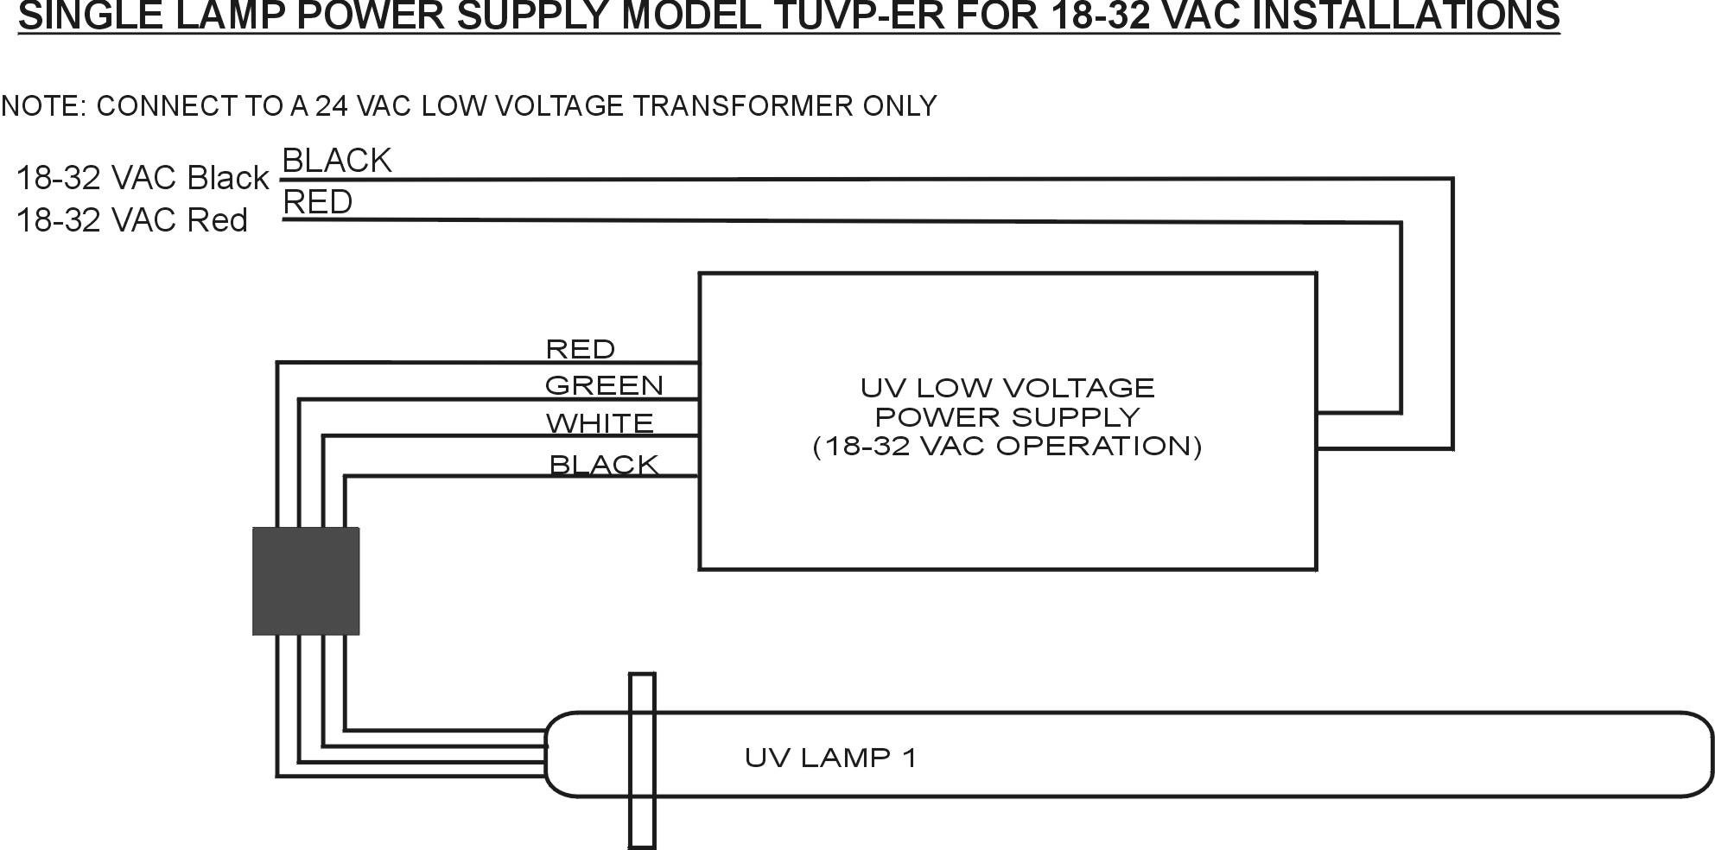
- For Multi-Voltage 120-277 VAC Power Supply Installations: Locate the control panel of the PTAC or fan coil unit and the main power terminations coming into the unit. The multi-voltage power supply can connect directly to the main line wire terminals (L1 and N for 120 VAC or L1 and L2 for 208-277 VAC). Use the supplied self-taping sheet metal screws to mount the power supply in place.

High Voltage Electrical Diagram:
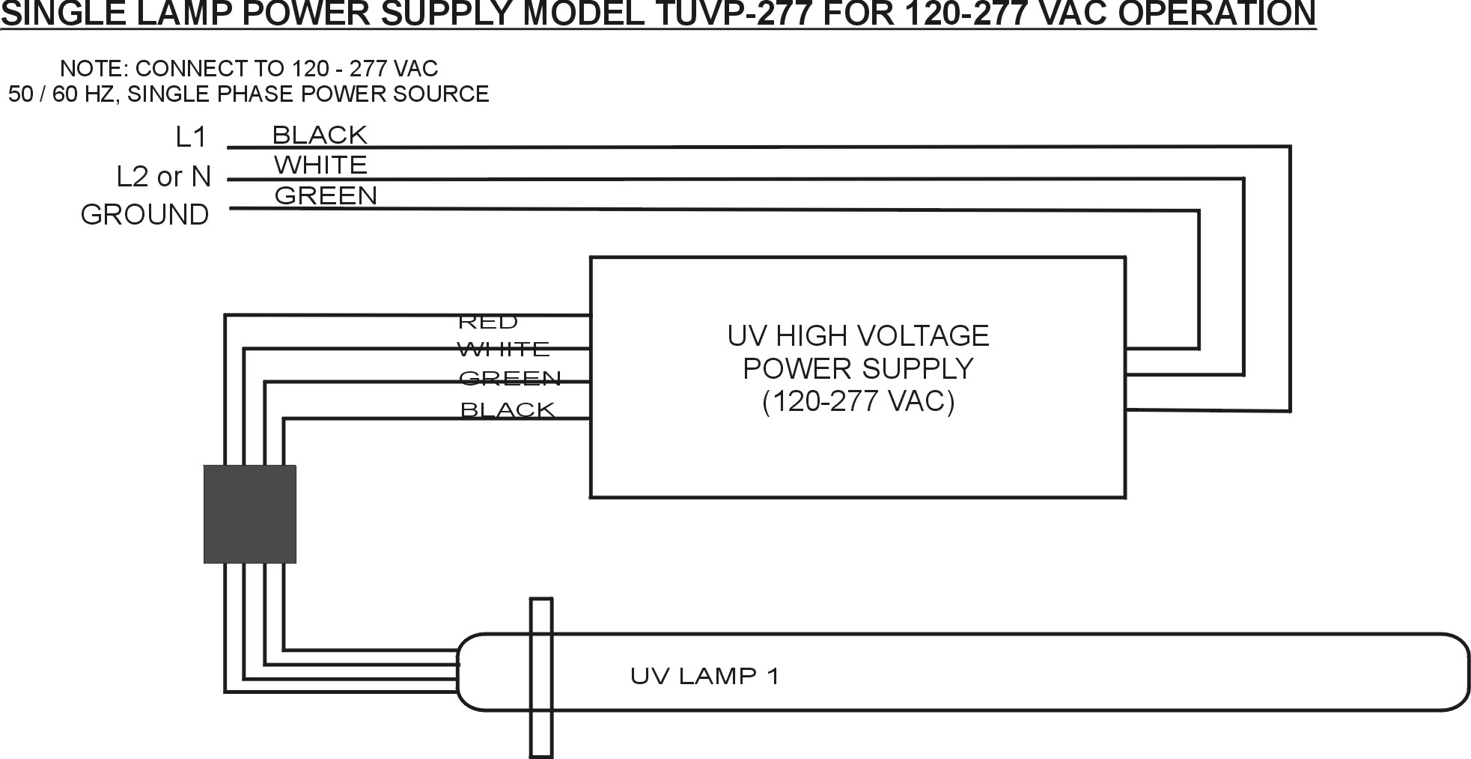

- ENSURE the main power to the air handler is turned OFF before proceeding. Refer to the electrical diagram for proper connection of the power supply to the low voltage power source. CONNECT IN ACCORDANCE WITH ALL STATE AND LOCAL ELECTRICAL AND BUILDING CODES.

Final Connections and Installation Wrap-Up
- Connect the waterproof remote cable male plugs on the power supply to the waterproof lamp female receptacles. The connectors have alignment keys and need to be properly seated during connection of the UV lamp will not light. Dress any excess remote cable into the air handle and secure. Refer to the diagram below for reference:
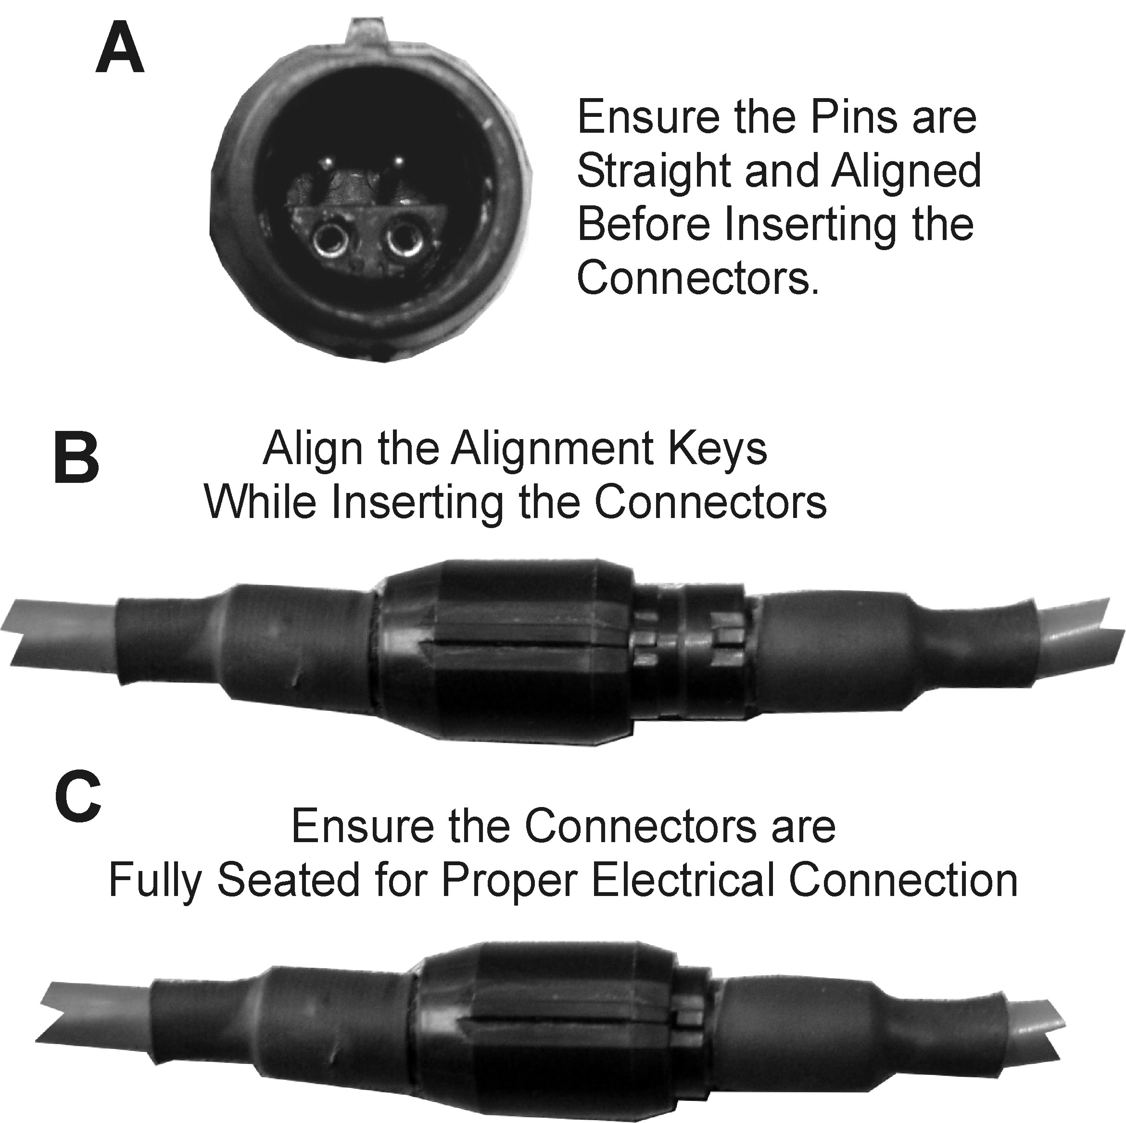

- Replace all access panels to the air handler. Caution: This product emits Ultraviolet light that can cause Serious Eye Burns and Temporary Blindness, Ensure all access panels have been replaced before proceeding to the next step!!!!
- Re-apply power to the air handler.
- Check that the lamp(s) have lighted, Typically within 5 seconds of applying power.

Maintenance:
Periodic Maintenance
Periodically wipe the UV lamps with a clean cloth or alcohol swab to remove any accumulated dust or dirt. This should be performed at least once per year or during routine maintenance intervals.

UV Lamp Replacement Intervals
Replace the lamps after the lamp has reached the end of its’ expected service life regardless of whether the lamp is still lit or not. This is because the UV lamps loose their germicidal effectiveness in time as the gas required to create the UV light is expended over time. This procedure should only be attempted be a trained service technician. Ensure all power is disconnected and the UV lamp is OFF before opening any of the service panels to the air handling system. The UV Lamps contain Mercury – Dispose of properly in accordance with all federal, state and local laws (Refer to www.lamprecycle.org)

Please contact your local dealer for replacement lamps.

Trouble Shooting Guide
Problem | Solution
UV Lamp Not Lighting | - Check that power is applied.  - Ensure the remote lamp cables are properly connected.  - Consult Factory.
UV Lamp(s) Flickering | - UV Lamp(s) have reached end of effective service life. Install new lamp(s) of same type.  - If unit is new, check remote cables to ensure they are properly connected.  - If new lamps still flicker, consult factory.
UV Lamps Have burned Out Prematurely | - Consult Factory.
Power Supply Will Not Light UV Lamps even after new lamps are installed | - Consult Factory.

5-Year Power Supply Warranty:

This warranty supersedes and replaces any warranty statements orally made by the Sales Person, Distributor or Dealer or contained in the written instructions or other Brochures or informational documents in relation to this product. This warranty gives you specific legal rights, and you may also have other rights which vary from State to State.

Manufacturer warrants the Tight-Fit Kit to be free from defects in material and workmanship under the normal use and service when operated and maintained in strict accordance with manufacturer’s instructions for the period of 5-years from the date of purchase of equipment, with exception of the Ultraviolet Lamp, which is warranted for UV germicidal output only for the following: TUVL-100F series – one (1) year; TUVL-200F series – two (2) years. The UV lamp warranty does not cover cracked or broken lamps due to mishandling or improper application.

Manufacturer’s obligation under this warranty is being limited to repairing or replacing any part found to its satisfaction to be so defective. This warranty does not cover parts damaged resulting from misuse, abuse, or any other than its intended use, accident, neglect, or from improper operation, maintenance, installation, modification or adjustments. Triatomic Environmental, Inc. shall have no responsibility for charges incurred by the customer for installation or removal of warranted items.

This warranty does not cover parts or equipment used with the TIGHT-FIT Kit that are not made by Manufacturer, since these items are covered by warranties of the respective manufacturer. This warranty shall be void if UV lamps from manufacturer’s other than Triatomic Environmental, Inc. are used with this equipment.

Manufacturer assumes no liability for any harm, which may occur as a result of the use of the equipment herein and shall not be liable for consequential or any other damages whether or not caused by manufacturer’s negligence or resulting from any express or implied warranty or breach thereof. Consequential damages for the purpose of this warranty shall include, but not be limited to, loss of use, income or profit, or loss of or damages to property or injury or death to persons or animals occasioned by or arising out of operation, use, the operation, installation, repair or replacement of the equipment or otherwise.

THERE ARE NO WARRANTIES WHICH EXTEND BEYOND THE DESCRIPTION ON THE FACE HEREOF

To obtain warranty service you should contact your local dealer or the part should be shipped at your cost to:

Triatomic Environmental, Inc.
1410 Park Lane S, Ste# 3
Jupiter, FL 33458
www.freshaireuv.com, sales@freshaireuv.com

Triatomic Environmental, Inc is the manufacturer of the Fresh-Aire UV, Tight-Fit Kit and Blue-Tube UV Brands.

